**Level Objectives & Sprites**

**List for 1st Level (Introductory level)-Night out police station**

Objectives:

“Player spawns in the office”

* **(MAIN)** Talk to the front-desk clerk about the recent reports of violent outbursts.
* **(MAIN)** Go to the armory and find the ammunition, flashlight and weapon to use for defense.
* **(Side quest)** Go back and talk to the front desk officer to get further information about reports. (The clerk informs the character of the showers which have extra bandages)
* **(Side quest)** Go practice aim in the shooting range.
* **(MAIN)** Go to the garage and try to leave with vehicle. (Fails as the fuse box controlling the garage door is down)
* **(MAIN)** Find the backdoor key in the cellblock area and use it to leave the police station.

LEVEL LAYOUT (Completed)



**List for 2nd Level (Street)-Nighttime**

Objectives:

“Player spawns at beginning of alleyway”

* **(MAIN)** Go through the shops and find a way out of the city.
* **(Side quest)** Find more ammunition at one of the shops. (Player searches the gun shop at the beginning of the level to try and find ammo, discovering more gun types

**SMG AND SHOTGUN**)

* **(MAIN)** Find the police transponder and get information on the location of the family. (police cars with transponder are surrounded by zombies, ammo and guns needed to clear zombies)
* **(Side quest)** Investigate the other shops and check for survivors.
* **(Side quest)** After contacting family, stock up on resources and find a way out of the city without being eaten.

Sprites:

* Ground color of alleyways (Concrete Grey)
* Roads (Yellow outer lanes)
* Walls of different colors for the building walls.
* Garbage dumpsters
* Boxes
* Bins (Spilled and not spilled)
* Roads and lanes
* Sidewalk (Grey)
* Benches
* Wooden wall planks (Brown)

* Doors of different colours
* Police Cars (Broken and not broken)
* Barbed wire
* Police Barricades (Burnt and not burnt)
* Cones
* Sewer covers
* Garbage bags
* Signs and logos
* Food carts
* Streetlights *angled down
* Broken glass
* Fire Engine
* Fire hydrants
* Ambulance (raided and broken and some not broken)
* Rubble
* Police tape (yellow and black)

Shops:

[Restaurant]

* Circular Tables and chairs, Square Tables and chairs, Bar shelf with contents, Bar stools, silver rack, Checkered Floors, Cleaning materials, Contents to put on top of desks and tables, Spills, Broken tables and broken plates

[Gun shop]

* Gun display case, Dummy targets, Clothing racks, Ammo crates and cases (large and grey), Ammo shells on the ground, **Guns and Ammo**

[Bookstore]

* Shelves with Books, Tables with chairs, Few computers, Printers, Scanners

[Retail shops]

* Till checkpoints, Isle with contents, Shopping carts, Refrigerators, Meat lockers, Meat racks, **Water and Materials**

[Utility store]

* Ladders and different tools, wheelbarrows, lawnmowers, other generic stuff, **Batteries for Flashlight**

[Clothing store]

* Clothes racks, clothes on ground, cash registers, changing rooms, bucket and mop, changing couch stools, small chairs

[Dinner store]

* Dinner couch, Dinner Tables, long serving desk, stove, condiments, storage units,

Food, plates and stuff

[Pharmacy]

* Shelves with medicine, medicine on the ground, small trolleys, water spillages, chairs, **Bandages**

Level Layout (Prototype)

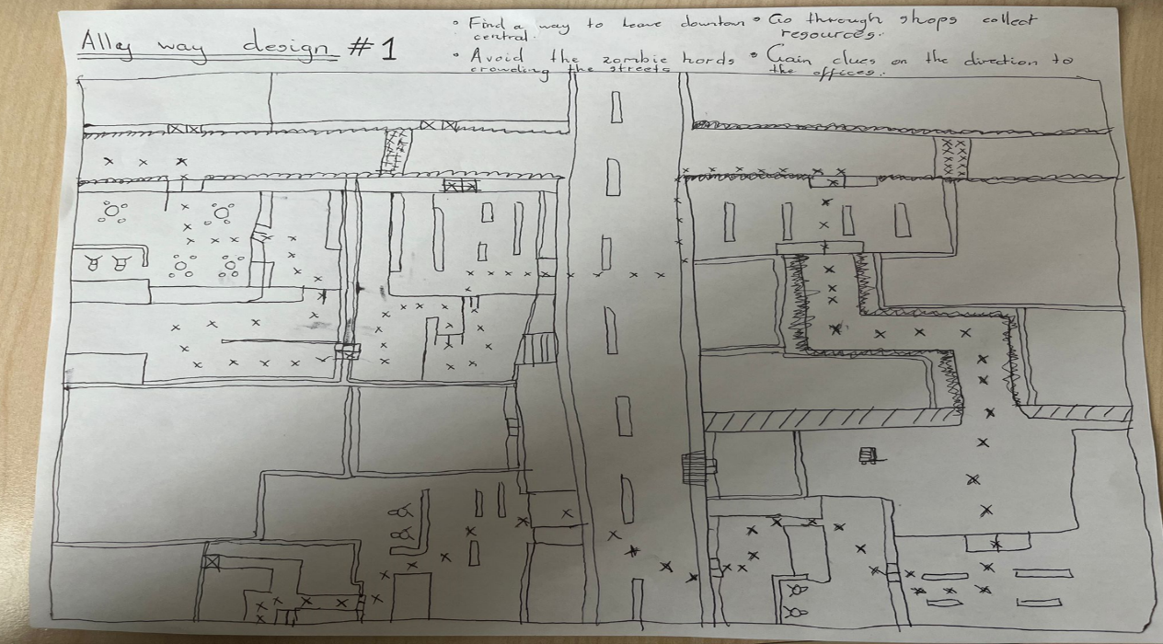

**List for 3rd Level (Office Building) 1-3 layers**

Objectives:

“Player spawns in garage (lower level of office building)”

* **(MAIN)** Find the reason for the power outage and fix it.
* **(MAIN)** Clear group of zombies gathered in the hallway that leads to generator room.
* **(Side quest)** Clear group of zombies in the rest of the parking garage.
* **(MAIN)** Find the circuit cables needed to complete the circuit for power.
* **(MAIN)** Find the keycard needed to access the upper level.
* **(Side quest)** Explore where the second keycard leads and clear out the zombies (These are a tough group of zombies, but pathway leads to a powerful weapon, most probably an AR of some sort or something or an easter egg in the game)

Sprites:

* Floors for this level will be a mix of concrete grey and tarmac black
* Walls for the environment
* Storage units
* Bars (restricting access to certain levels)
* Fuse box
* Electrical wires
* Generator object
* Vehicles (Broken and not broken)
* Garage doors
* Fire Extinguishers
* Fire hoses
* Light fixtures on walls
* Cleaning materials
* Benches
* Fuses
* Rubble on the ground
* Keycard
* Keycard unit
* Parking lanes on road

Level Layout (To be proposed)

**List of 3rd Level (Office Building) 2-3 layers**

Objectives:

“Player spawns at door leading to Garage level (in office building)”

* **(MAIN)** Search the office cubicles for family
* **(Side quest)** Check for survivors in the break rooms
* **(MAIN)** Gather evidence to try and figure out where your family could be
* **(MAIN)** Follow the blood trail to where it leads
* **(Side quest)** Clear the office area and break rooms of the zombie hordes present
* **(MAIN)** Investigate what happened at the office building

Sprites:

* Floors for office building (preferably light dim blue)
* Walls for office building
* Office desks and chairs
* Office cubicles
* Office printers, scanners and stuff
* Whiteboards
* Paper Trails and stuff
* Trail of blood
* Broken glass
* Broken desks, chairs and cubicles
* Rubble on the ground
* Fire extinguisher and hose
* Potted Plants
* Computers and office CPU’s
* Kitchen stuff
* Refrigerators
* Microwave
* Kitchen sink
* Pool of water and some blood

Level Layout (To be proposed)

**List of 3rd Level (Office Building) 3-3 layers**

* This will be the final level of the game and where the player concludes their journey

Objectives:

“Player spawns at the outside of the office building (on the highest level)”

* **(MAIN)** Find a way to reach the end of the construction zone
* **(MAIN)** Clear the zombies blocking the pathway to the end of the building
* **(Side quest)** Pursue the separate trail of blood leading to another place (Another easter egg that leads the player to more ammunition and a special weapon **LMG**, makes the final boss battle easier)
* **(MAIN)** Defeat patient zero (overpowered zombie) and go ahead to the final room to check on family

Sprites:

* Concrete blocks and pillars
* Cables and long rods of steel
* Caution signs
* Bright orange cones
* Clothing scattered
* Floors
* Walls
* Work benches
* Trail of blood (Green)
* Desk
* Lockers
* Computers
* Locked doors
* Dirt
* Sandbags and bags of cement
* Pile of stones
* Construction tools
* Glass shattered
* Glass panes
* Windowpanes

Level layout (To be proposed)